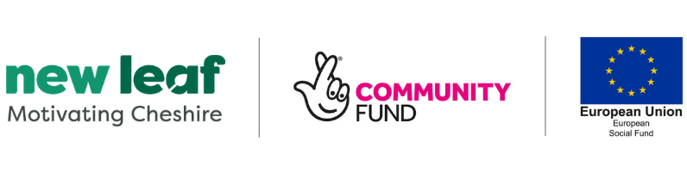

Role: To work in the local Community and engage with hard to reach residents to help
onto the New Leaf Programme.
Title: Community Energiser
Salary: National Minimum Wage
Hours: 16 hours

Fixed Term 6 month Contract.

New Leaf is a Building Better Opportunities project funded by the by European Social Fund and The National Lottery Community Fund. It is an innovative project, targeting individuals furthest away from the labour market in the Cheshire and Warrington Local Enterprise Partnership (LEP) area, to help them in their journey towards employment.

Led by Warrington-based Golden Gates Housing Trust, working in partnership with other organisations across the area, New Leaf will support 2,800 individuals over a three year period, providing a tailored service, giving individual support and direction.

The role is with the Disability Information Bureau. We are a small charity with a proud history. Established in Macclesfield in 1993, we provide holistic services specific to the needs of disabled communities across Cheshire East. Many of these people find themselves hidden from view and isolated from society, and all our resources go into combatting the risks they face. We do not spoon feed our cohort or wrap them in cotton wool. Instead our aim is simple – we encourage independence by empowering them to find the voice, confidence and resilience to make positive changes in their own lives - levelling the playing field when it comes to mental health, wellbeing, employment, and inclusive opportunities.

As Community Energiser, you will be active in your local communities, passionate about supporting people; a real ‘people person’ who can engage with hard to reach residents. Working alongside Professional Mentors, you will have a empathetic approach, personal understanding of barriers residents face and can provide non-judgemental advice and give confidence to access the programme

If you feel that you do possess the essential skills outlined in the Job Description then we would welcome your application.

This position is fully funded by the Building Better Opportunities project funded by the by European Social Fund and The National Lottery Community Fund.

To apply for this exciting role call 01625 501759 and ask for Leanne Lake, or email Leanne.lake@dibservices.org.uk

Key dates
• Closing date –26.07.19
• Candidates selected for interview will be notified week commencing – 29.07.19
• Selection event date –01.08.19

