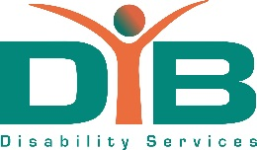
Mission
Provide services to empower disabled people, those with long term health conditions, vulnerable adults and Carers to improve their lives and wellbeing.

Vision
We wish to challenge and change attitudes so that society is fair and inclusive and everyone has equal opportunities to thrive and achieve their full potential.

Values
In the pursuit of our mission we will work to the following values:
- Welcoming – we will offer the hand of friendship and support to all those we provide services to, those who work and volunteer for us and all our partners.
- Inclusive – we will promote equal opportunities at all times and actively seek to work in partnership with others.
- Impartial – we will not be judgemental and act fairly towards all. The support and advice we provide will be independent and based on people’s specific circumstances.
- Dedicated – we will always go the extra mile in our care, consideration and support of others.
- Confidentiality – we will treat people’s information and the stories they share with us with respect and confidentiality.
- Accomplished – we will continually seek to develop the skills and gain further experiences and insight that help us to support and empower others.
- Celebration – we will recognise and celebrate people’s efforts, contributions and successes.

